Final Project Design Phase
Computer Science - Week 11
Oct 3, 2026 - Version 0.0.4

For complete instructions and project ideas, refer to the assignment in Canvas. Specifically, review the final project requirements before you continue below. If you have not reviewed the project requirements in Canvas (you might have to go to the modules view and check the current or past week's content), you will not be able to properly complete the parts below. In addition, it may be helpful to review the information on this Drafter documentation page.

0) Project Planning and Preparation
Successful programmers spend time planning before they begin coding. After reviewing the project requirements, answer the following questions to help guide your design and development process.
- What concepts from class or previous assignments might help you complete this project? Which programming concepts (loops, conditionals, lists, classes, etc.) do you expect to use? What programming skills do you want to improve while completing this project?
3 card poker, lists, conditionals and classes

- Which parts of the project do you expect to be the easiest for you? The hardest? Why?
The part of the project I expect to be the hardest is the algorithm that chooses what choice as that would be difficult to figure out, the part I expect to be the easiest t is the page ui, because it shouldn’t be too hard to program

- Even though you have not yet designed the final project, estimate which tasks will likely require the most time and effort? Which features or components should be implemented first?
The tasks that will require the most time and effort is the randomizer aspect of it, as I will have to come up with multiple and thinking up different selection methods could be difficult. The features that should be implemented first are these randomizers or selectors as they need to exist for the routes to work.

- What distractions might interfere with your work and how will you minimize them? What resources will you need available while working? What questions, if any, do you still have about the assignment requirements?
Some distractions that might interfere with my work could be my phone, and I will minimize it by putting it to the side while working on the project. I will need a computer to run the program, I don’t have any particular question about the assignment.

1) Site Diagram
Create a mock-up of your planned website. We suggest you make the mockup on paper, although you can also use software like PowerPoint or Slides to make a mockup. There is other design software that could also be used, but we strongly encourage you to keep it simple. Do not spend more than 15-30 minutes detailing the mock-up. Your goal should be to make a very quick and dirty diagram, to show that you have some kind of idea.

We recommend drawing each page as a rectangle, and laying out the text, buttons, and other components inside. Then, use arrows to indicate links between pages. Label each page the way you will name each function, and then put labels on the arrows to indicate what the button links. Also write down any parameters that should come into the pages.

In addition to the pages and routes, write down what fields your `State` will have, both their names and types. Think clearly about what data will need to be persistent across the entire website.

Add photo(s) or screenshot(s) of your website mock-up and labeled diagram on the next page.
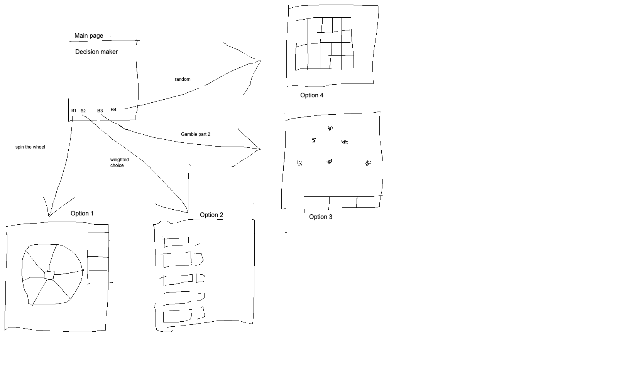

2) Implementing Requirements
This table should serve as a draft for how you will implement the requirements into your final project. You may change your ideas later on, but your final site must fulfill all the requirements.

Requirement | Implementation
Purpose/Functionality  A 1-2 sentence description of the purpose or functionality of your site | The purpose of the site is to give users a way to make decisions if they can’t come up with a way to choose.
State Dataclass Attributes  Minimum of 4 attributes, one of which must be a list/dict of instances of your second dataclass.  Briefly describe each attribute, its type, and how it will be meaningfully modified throughout the site. | Question -users question to be answer  Options- the list of choices  Selected_method: the method the user chooses  Result: the final result
Second Dataclass  Your second dataclass, including its attributes, their types, and how they will be meaningfully modified (if they are modified) | Decesion_option  Name- the name of the choice inputted by the user  Score- the weighted score of the option
Routes (minimum 7)  The names of your route functions | Index  Create  Methods  Wheel  Random  Gamble  Compare
Pages (minimum 5)  A brief description of the pages in your site | Home- the home page  Option1 - The wheel  Option2 - The weighted choice  Option3 - The gamble thing  Option4 - The randomizer
User Input (minimum 3)  Description of user input components (TextBox, TextArea, CheckBox, or SelectBox) and their purposes  For more information on these input types, see Drafter Documentation. | Textbox: What are you deciding  Textbox: for the choice1  Textbox: for the choice 2  Etc.  Home button: To return to homepage
If Statements (minimum 3)  Brief description of what will be evaluated in your if statements and how they will meaningfully change the logic of the site | An if statement to test if the user ever puts in anything blank or such  If statement for determining the highest weighted choice  If statement for if the weighted scores are tied
Loop (minimum 1)  This loop must iterate over the list/dict of dataclass instances in your State attribute.  Description of this loop and why it is meaningful to the site | Loop to go through list of choices inputted to display them or use them, like putting the choices on the wheel, it use meaningful to display the choices

LLM Conversation
If you used an LLM in any part of this work, copy and paste every part of that conversation below. Otherwise, you may be given a zero for the assignment. Obviously, these words will not all be yours, and this is the exception to the requirement at the top of this assignment that all responses be in your own words. If you did not use an LLM to assist you in this assignment, simply say so below.
Replace this text with your answer.

Final Submission
When you are finished, download this file as a Word Document (docx) and upload the file to the appropriate assignment on Canvas.

